- Configure classic load balancer.
- Create EC2 Instance
1. Go to EC2 Dashboard → Instances → Launch 2 Instance with public subnets running in the same region and having different availability zones.

2.Check the Security group whether it is having HTTP → Port no: 80 with Source : 0.0.0.0./0
3. If not provide access by Editing Inbound rules.

4. Connect to 1st instance
Install httpd → use : sudo yum install httpd -y
echo “welcome to Server-01”>> /var/www/html/index.html
sudo systemctl start httpd
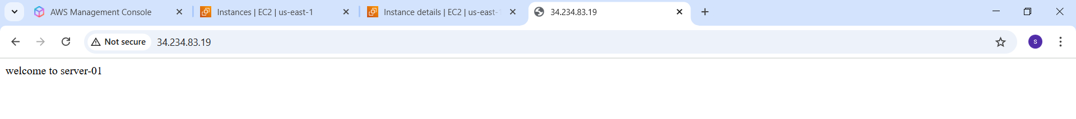
Similarly connect to 2nd instance
Install httpd → use : sudo yum install httpd -y
echo “welcome to Server-02”>> /var/www/html/index.html
Sudo systemctl start httpd
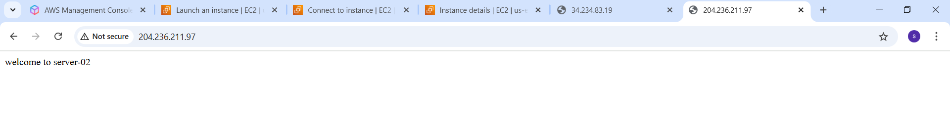
- Create classic load balancer
Go to EC2 → Load balancer → create load balancer
Select Classic load balancer
Enter load balancer name :
Select internet-facing in load balancer scheme
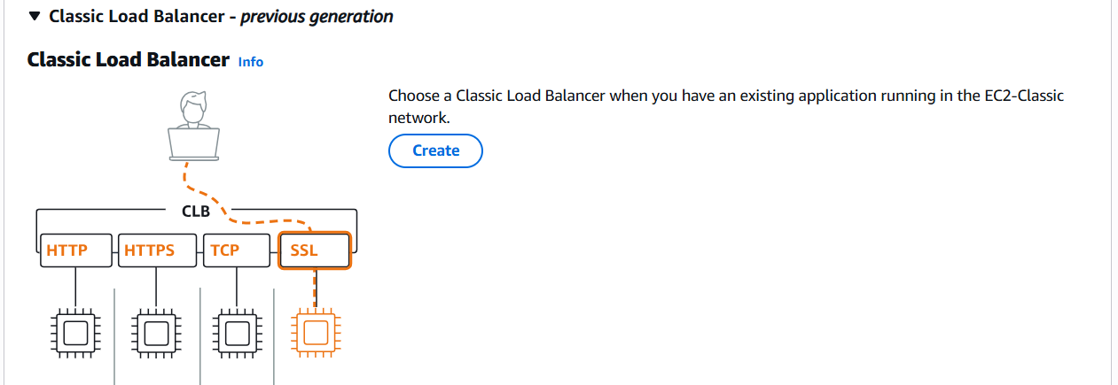
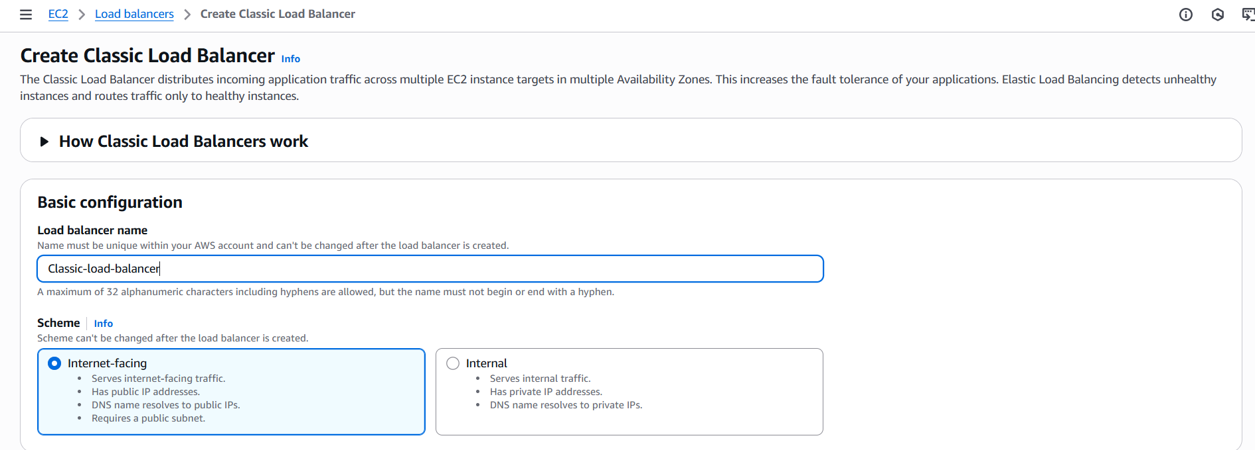
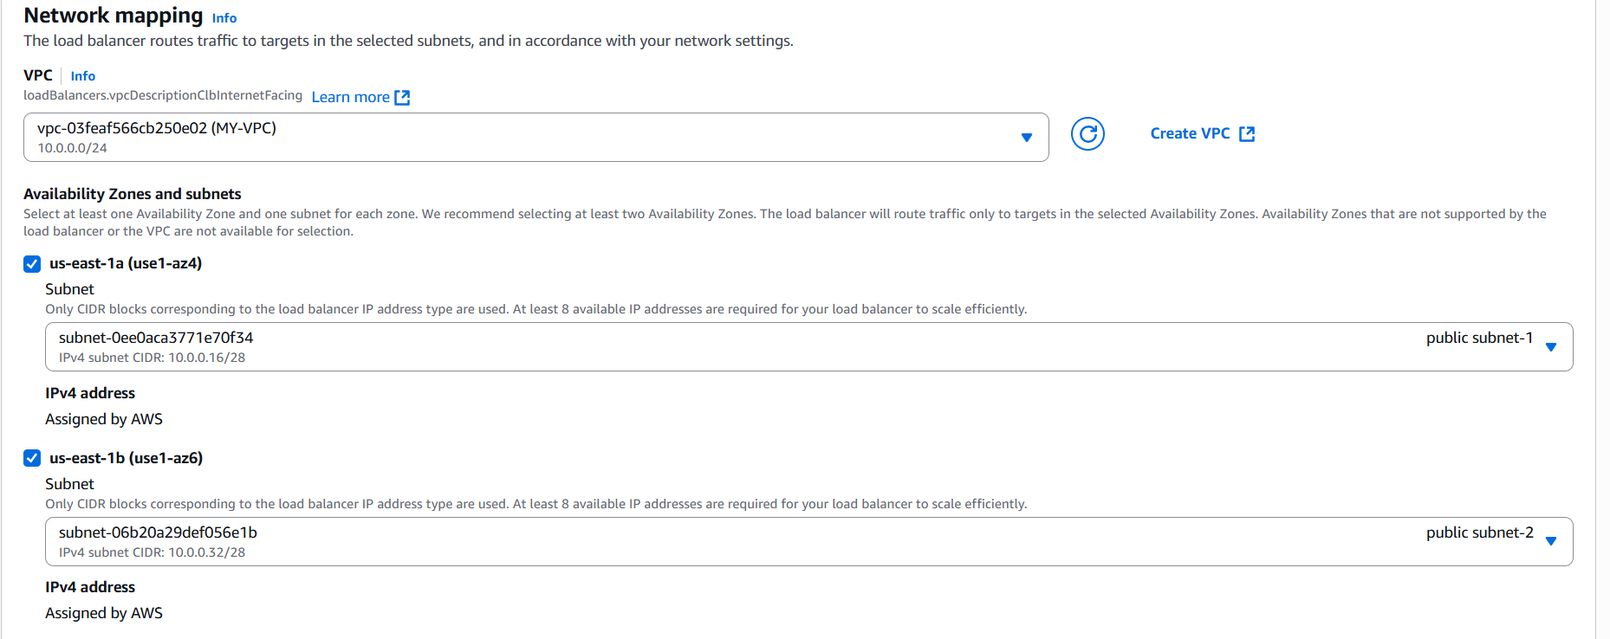
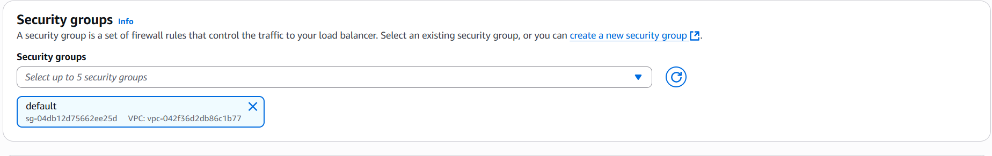
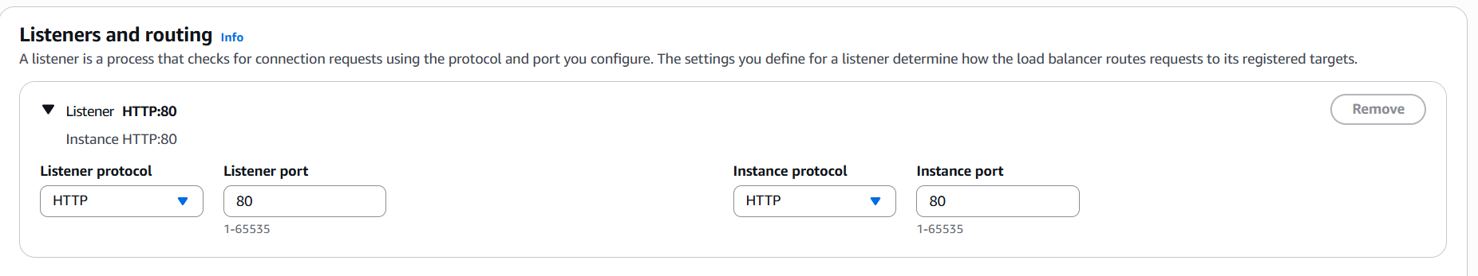
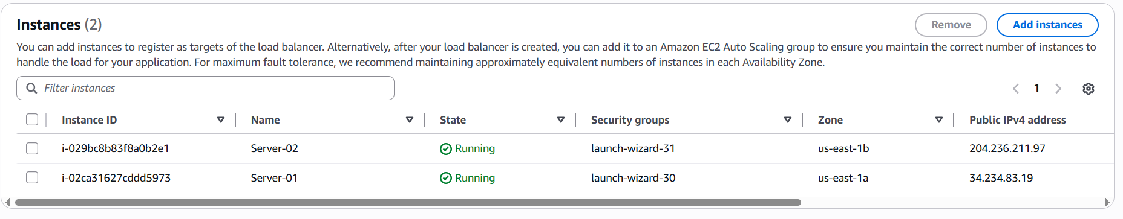
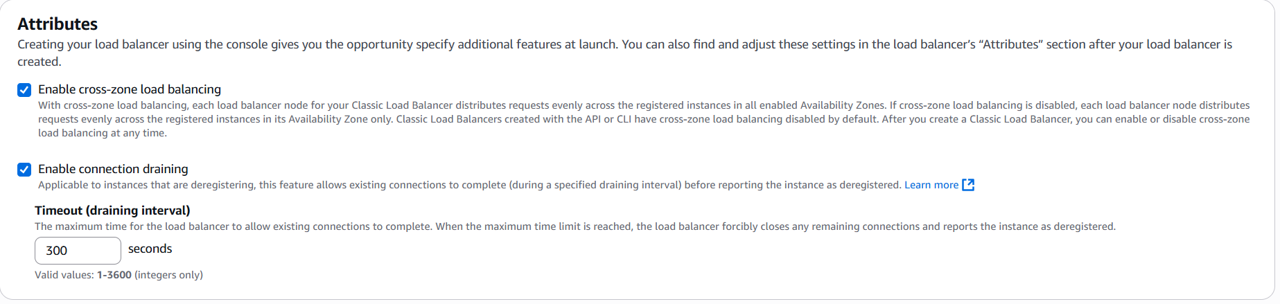
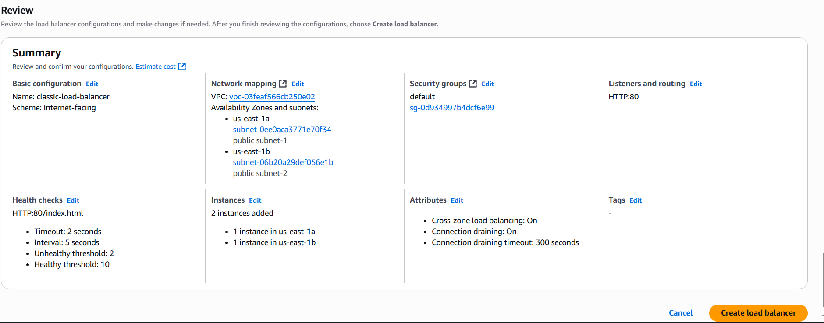
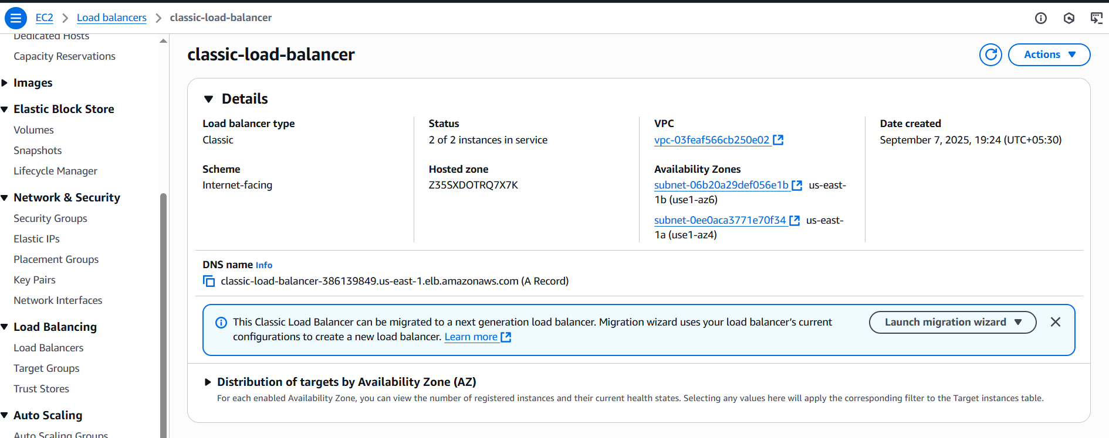
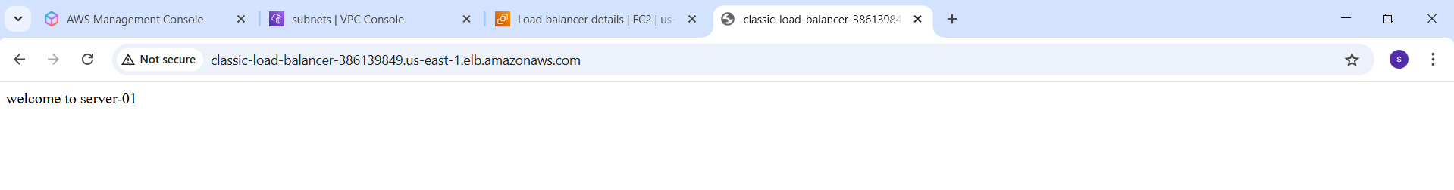
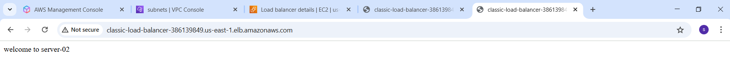
- Configure Application Load balancer.
Step-1:
Create instance with public subnet


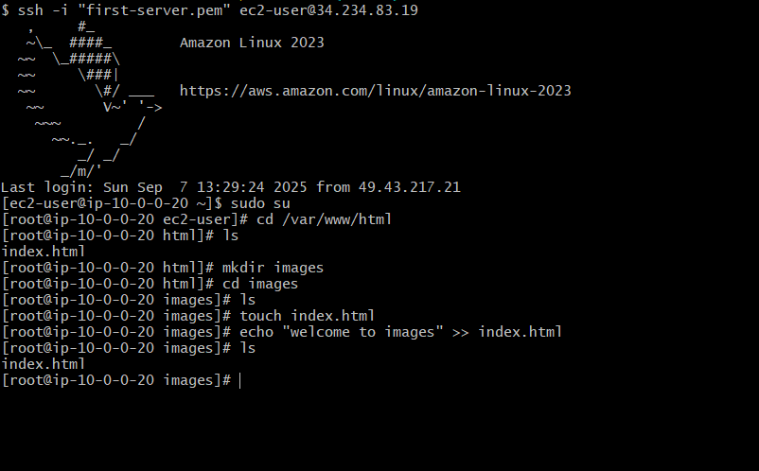

Step-2:
Create Target Groups
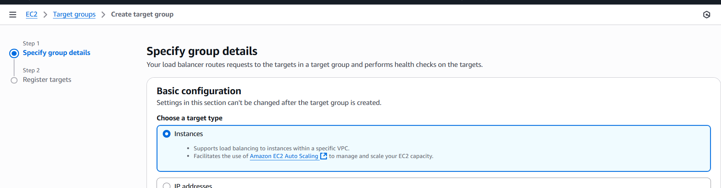
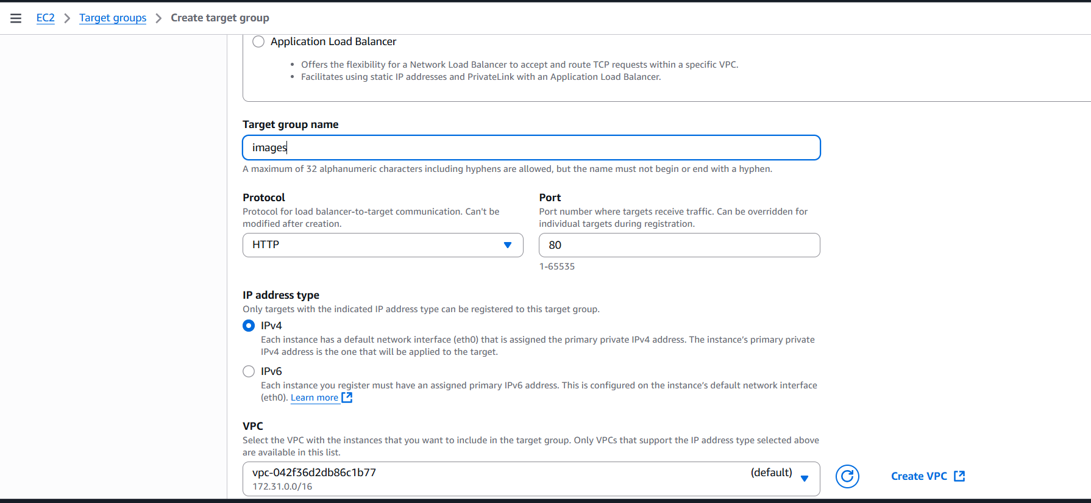
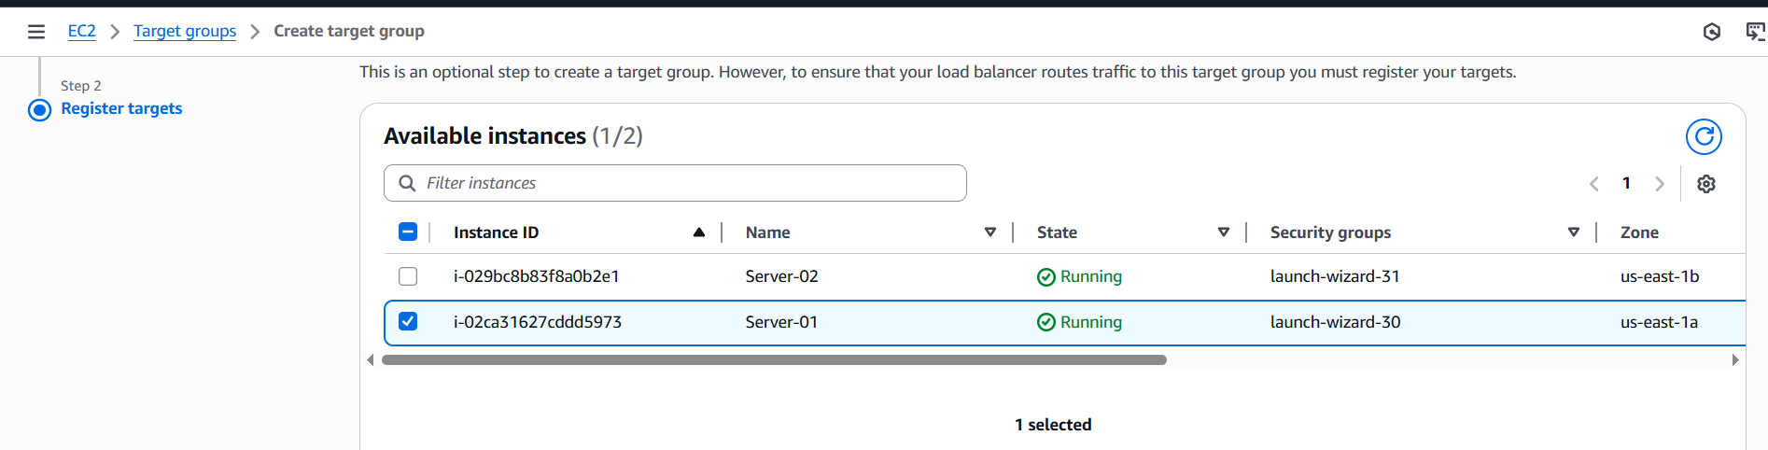
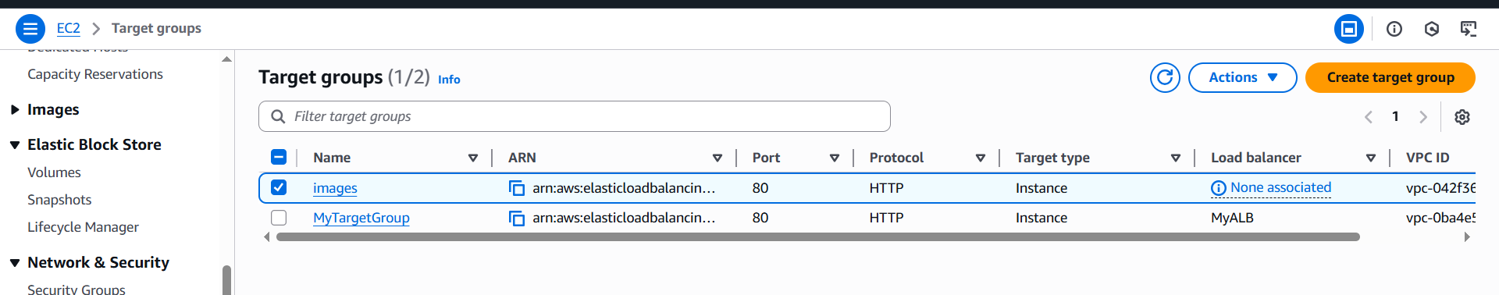
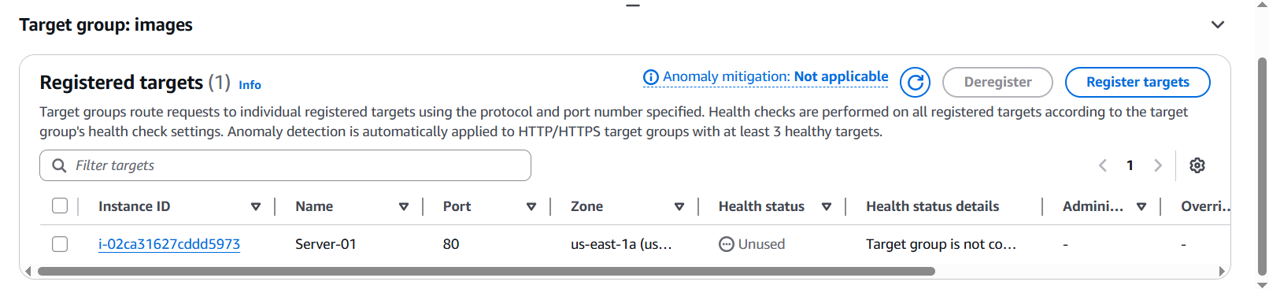
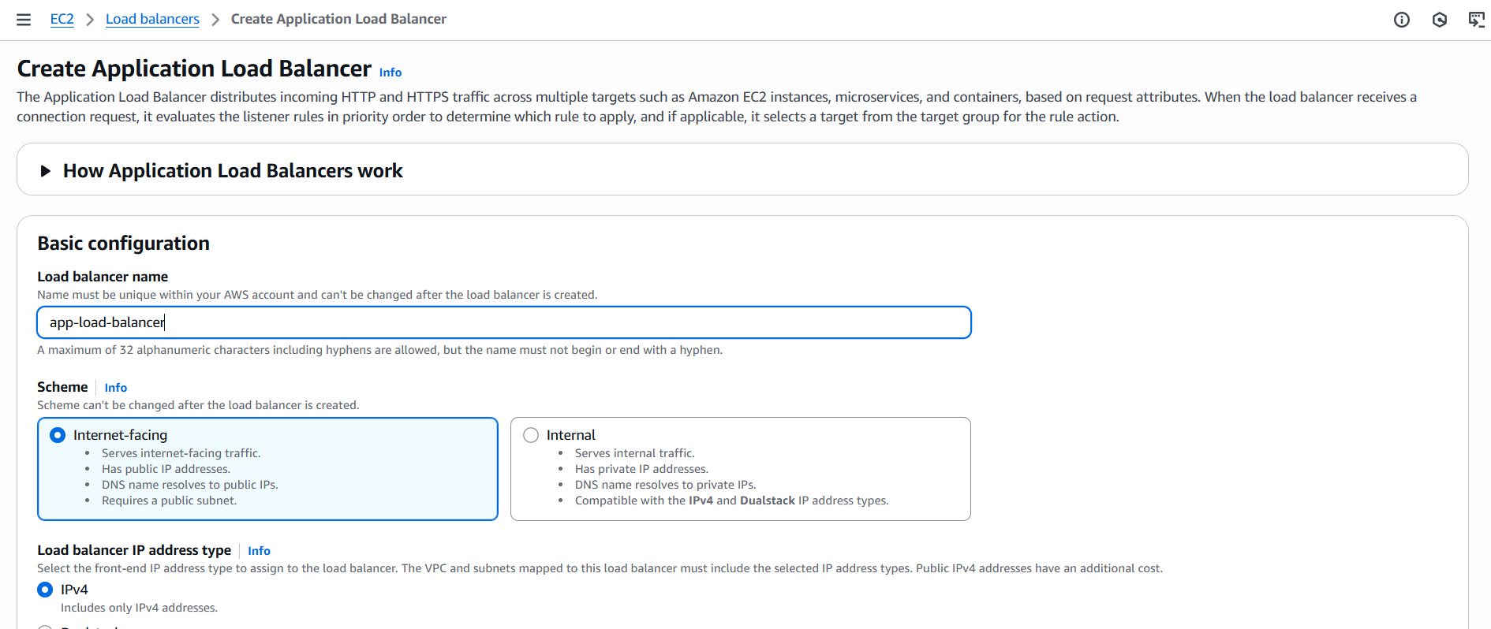
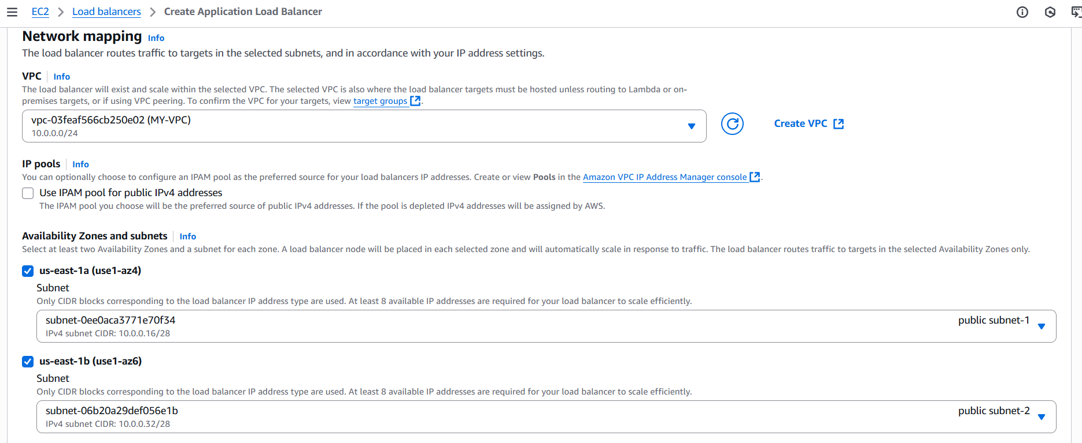
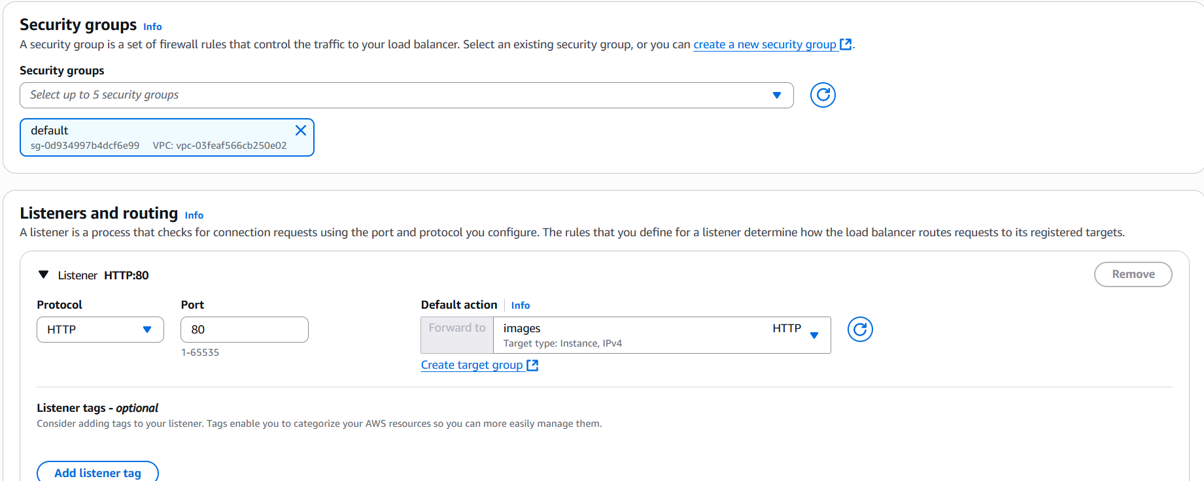
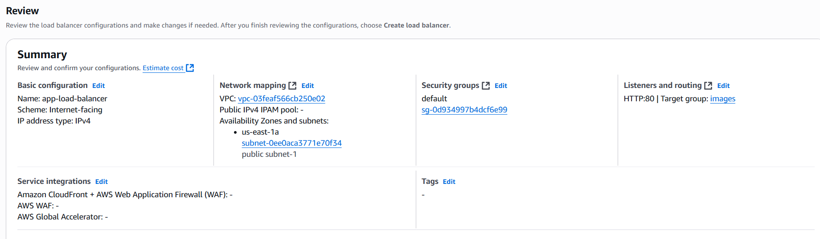

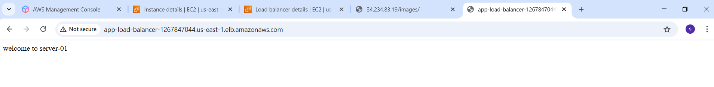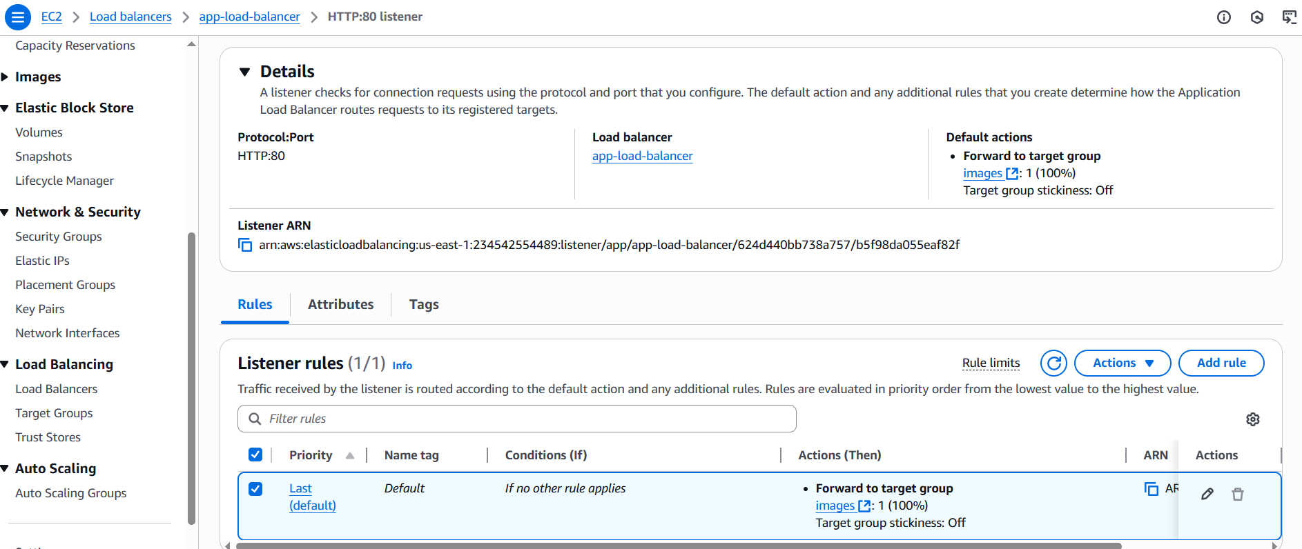
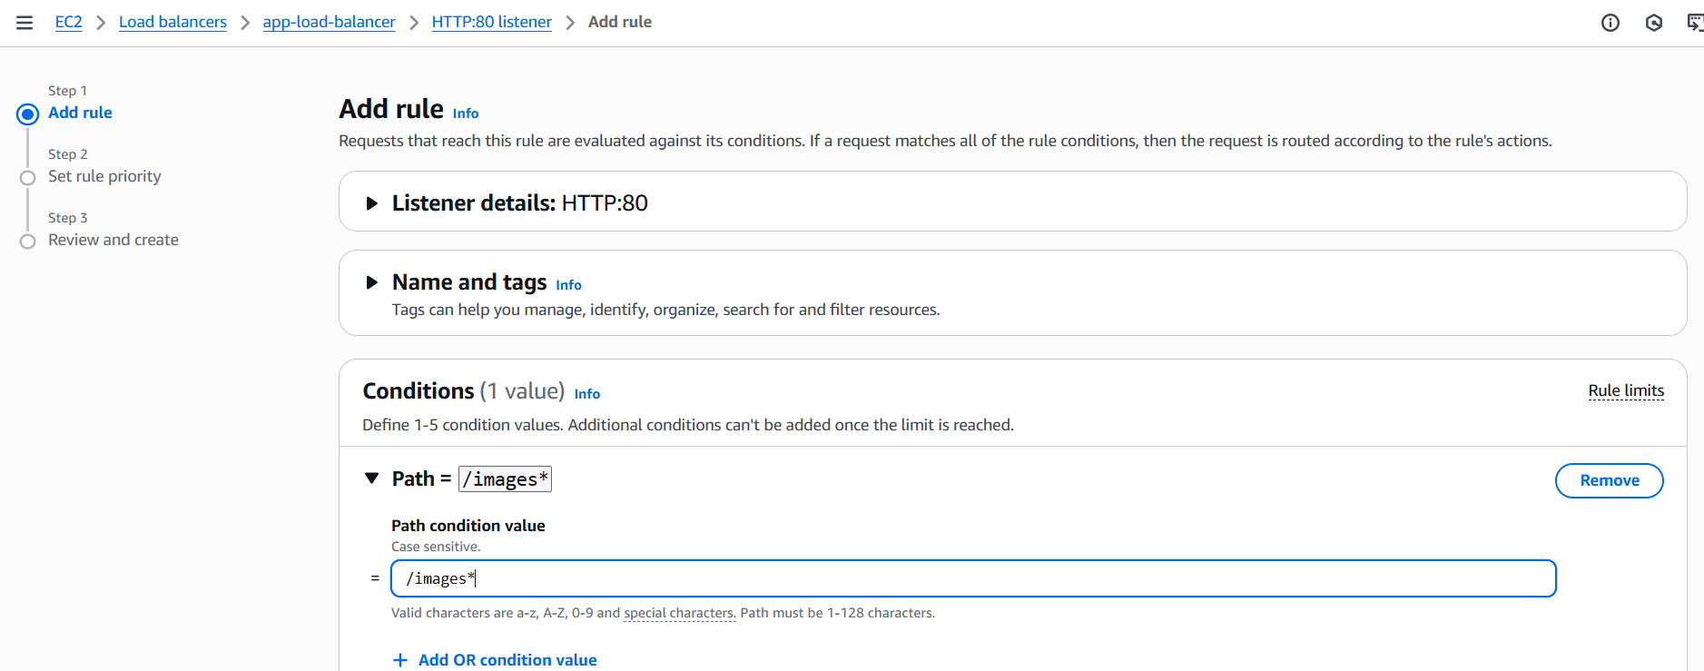
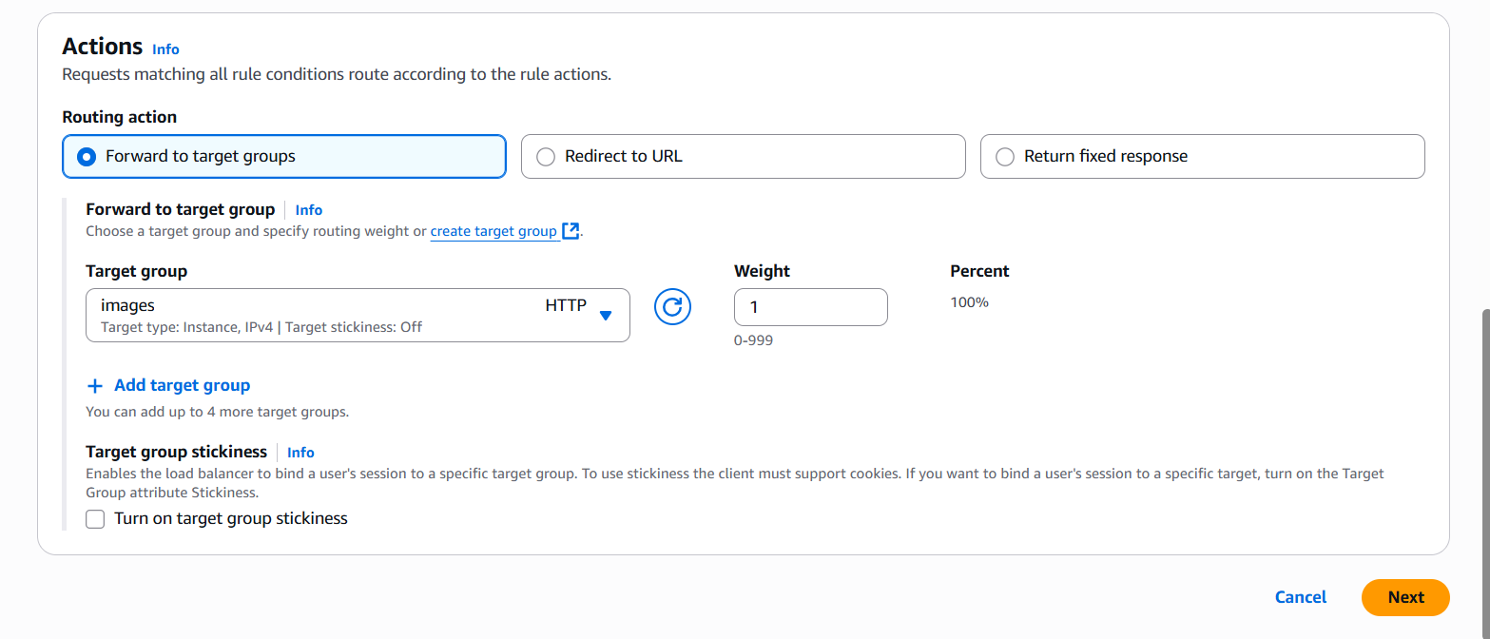
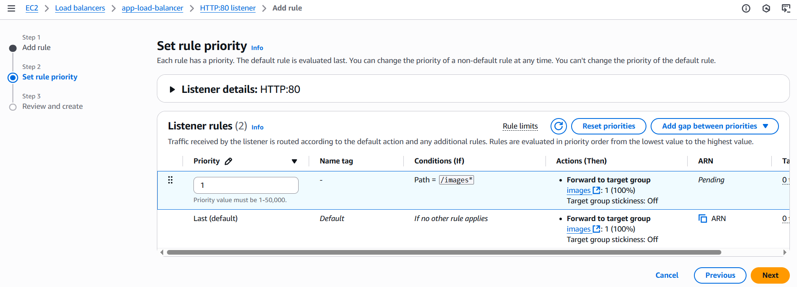
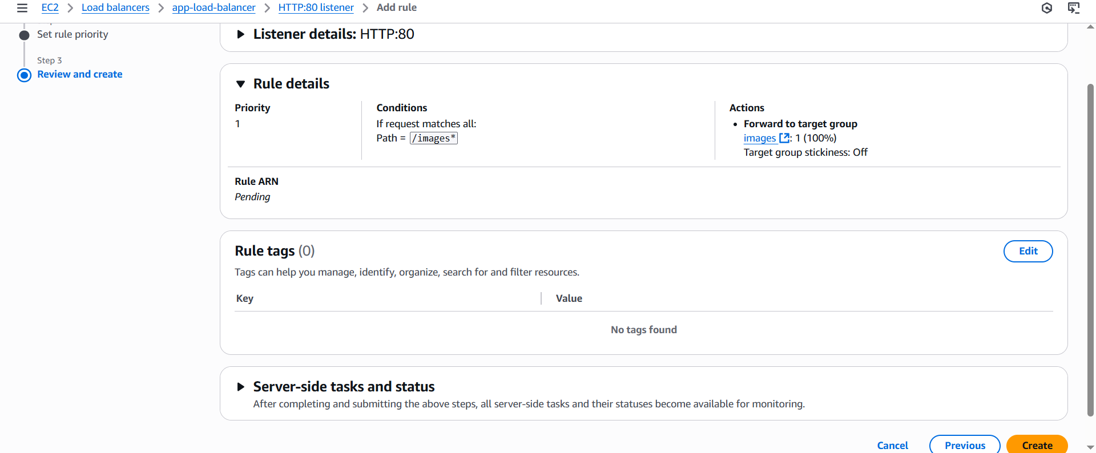
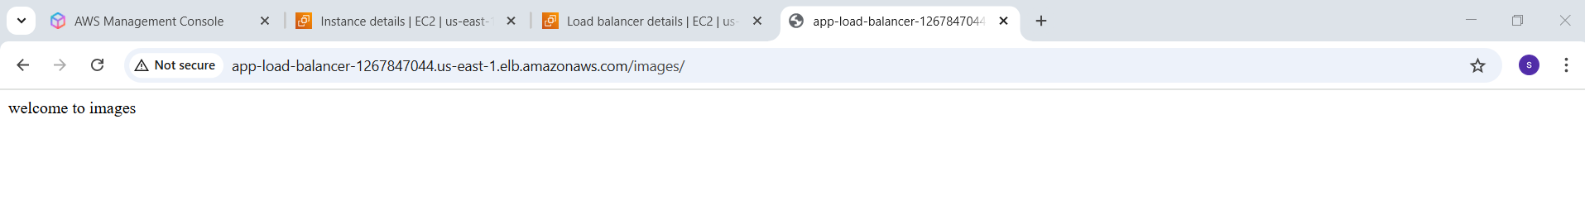
- Configure Network Load balancer.
Step-1:
Create instance with public subnet
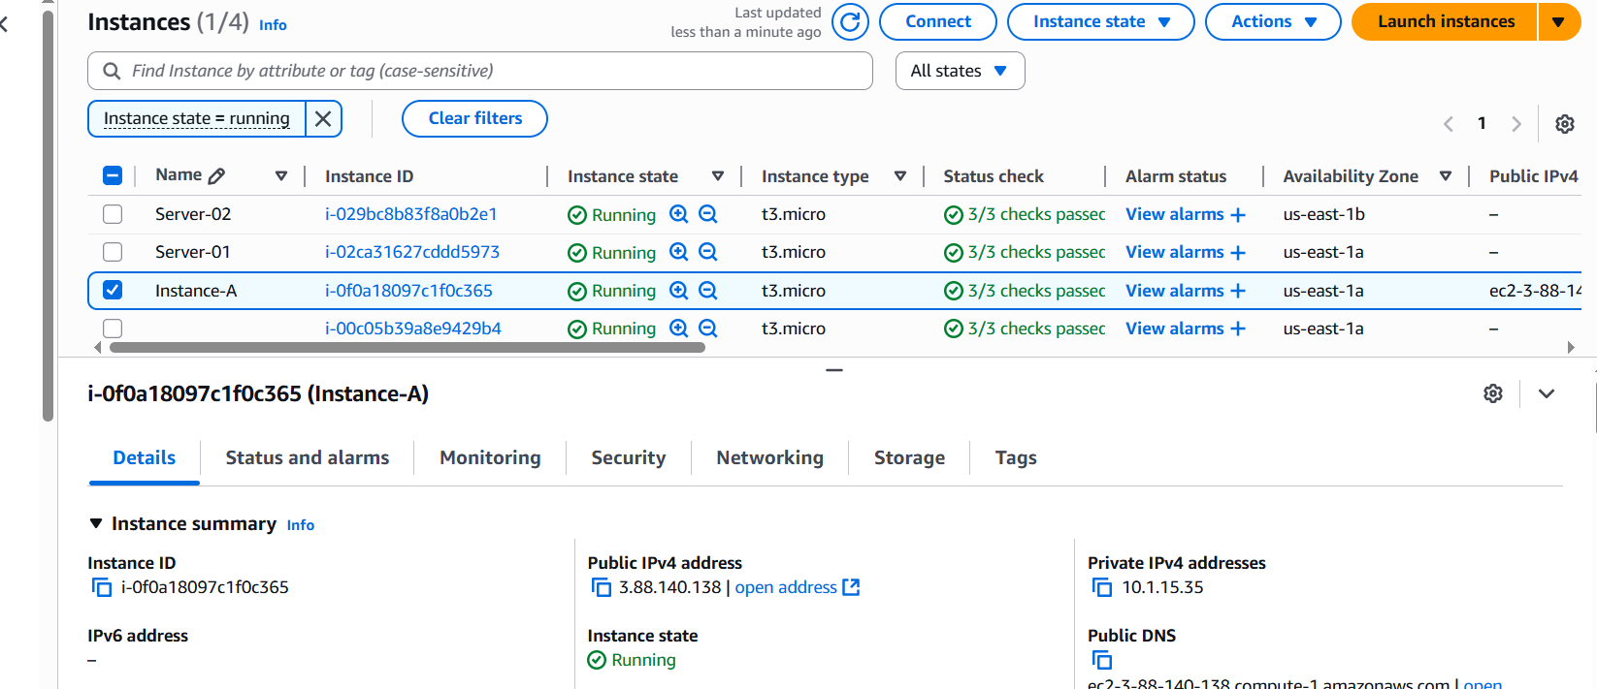
Step-2:
Create Target
EC2 → Target groups → Create target group
Select instance in target type
Select protocol TCP port no: 80
Select VPC which is used in your instance
Select IPV4 in IP address type
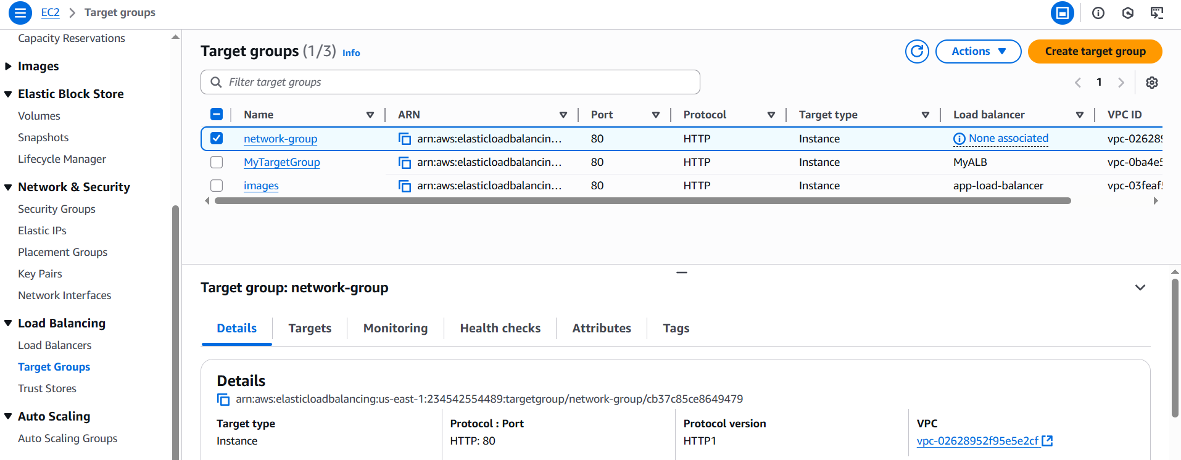
Step-3:
Create Network Load balancer
EC2 → Load balancers → Create Load balancer → Select Network Load balancer

Enter Load balancer name
Select Internet-facing in scheme
Select IPV4 address type
Attach your Target group in Listeners and routing
Click Create load balancer
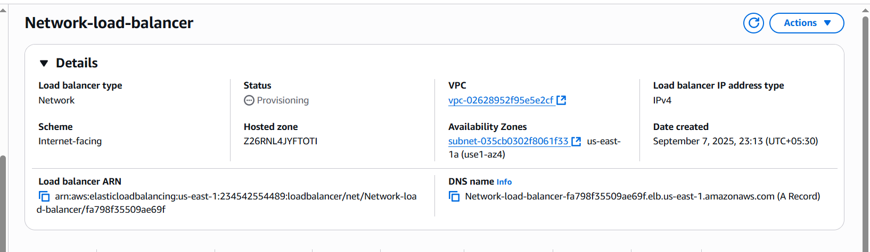
- Attach SSL for Application load balancer
Process:
- Create an Application load balancer (Already created)
- An SSL/TLS Certificate in AWS Certificate Manager (ACM) (Either created in ACM or imported).
- ALB must be in atleast 2 subnets in different Availability Zones.

Step-1:
Create Application load balancer
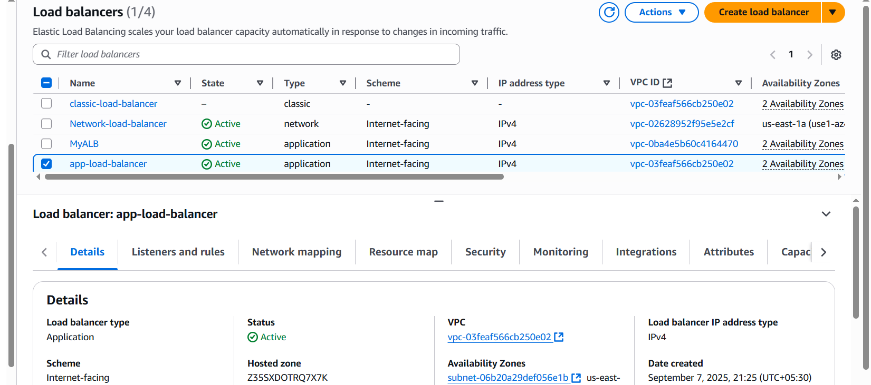
Step-2:
ACM → Certificates → Request Certificate → Request Public Certificate
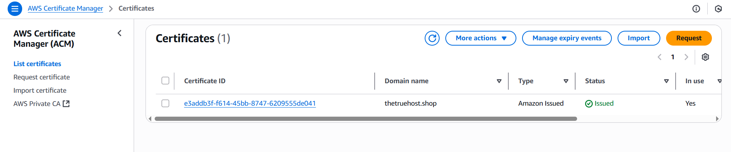
Step-3:
Edit ALB Listener
EC2 → Load balancer → Select your ALB → Click Listener tab
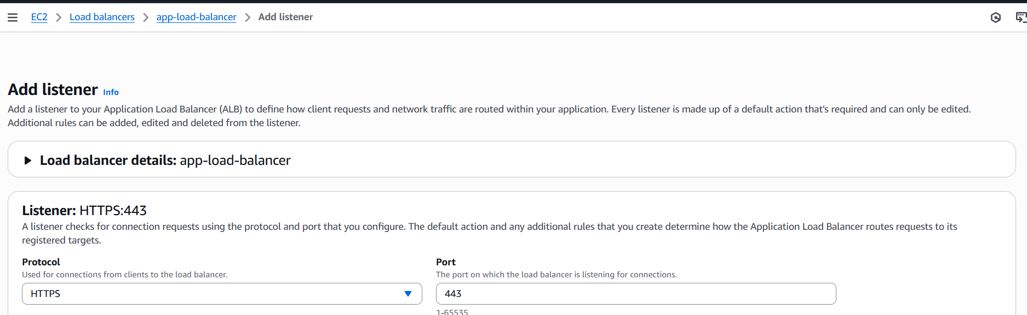
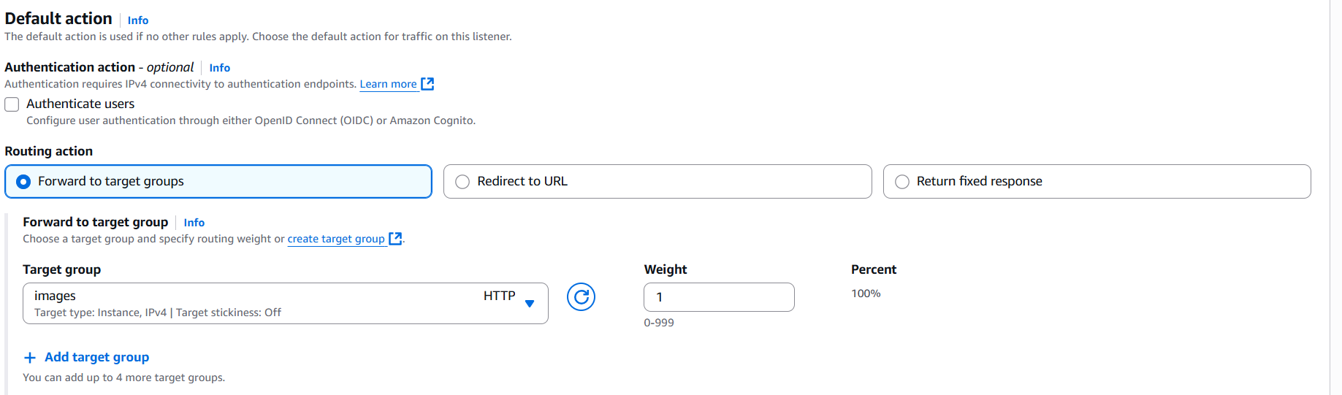
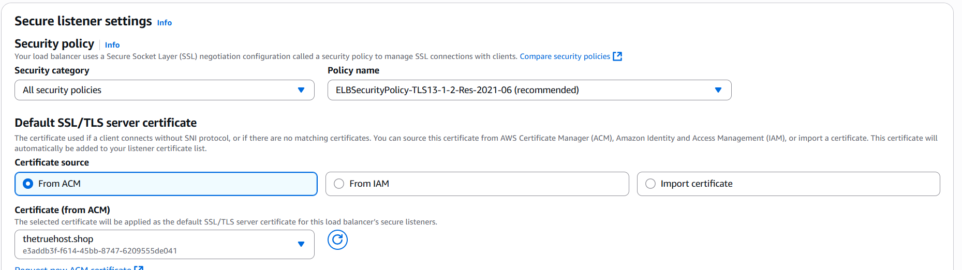
Click on Add Listener.
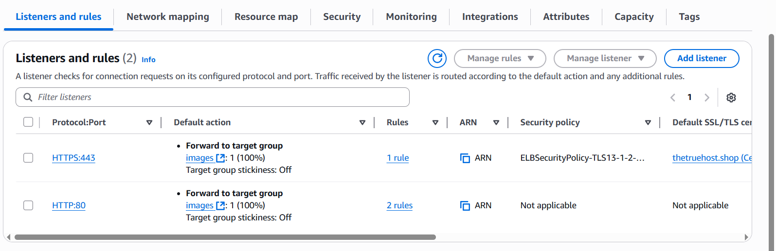
- Map Application Load balancer to R53.
Step-1:
Create Application Load balancer (we already have application load balancer)
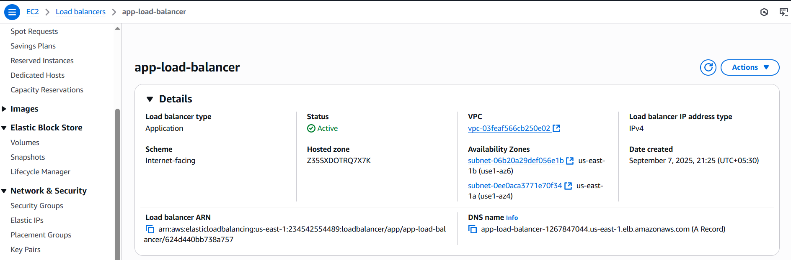
Step-2:
Go to Hosted zone, Click Create Record.
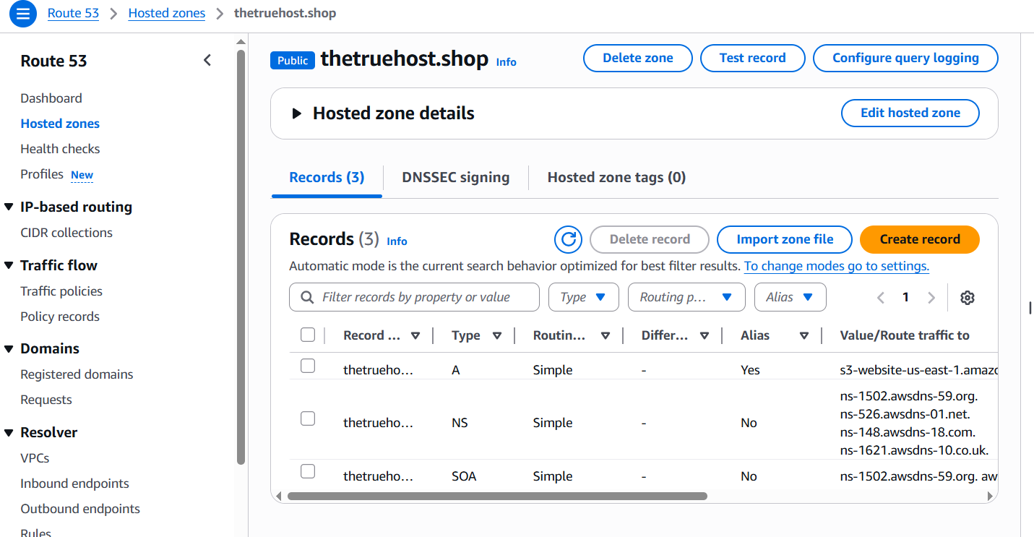
Select Record type A
Select Alias to Application and Classic load balancer
Select Region and select your Application load balancer
Click create Record.
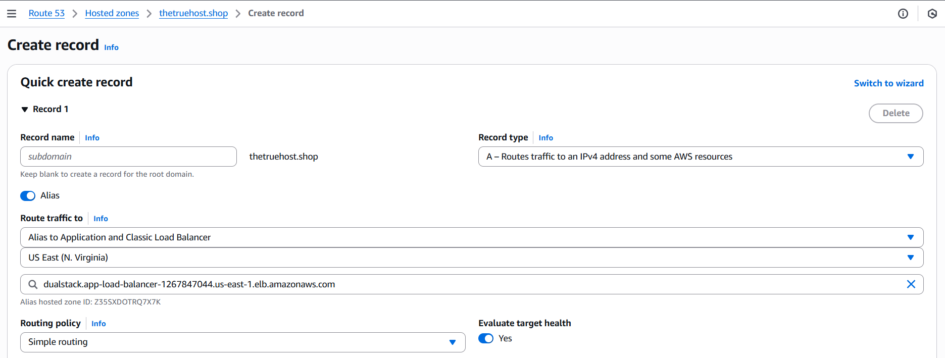
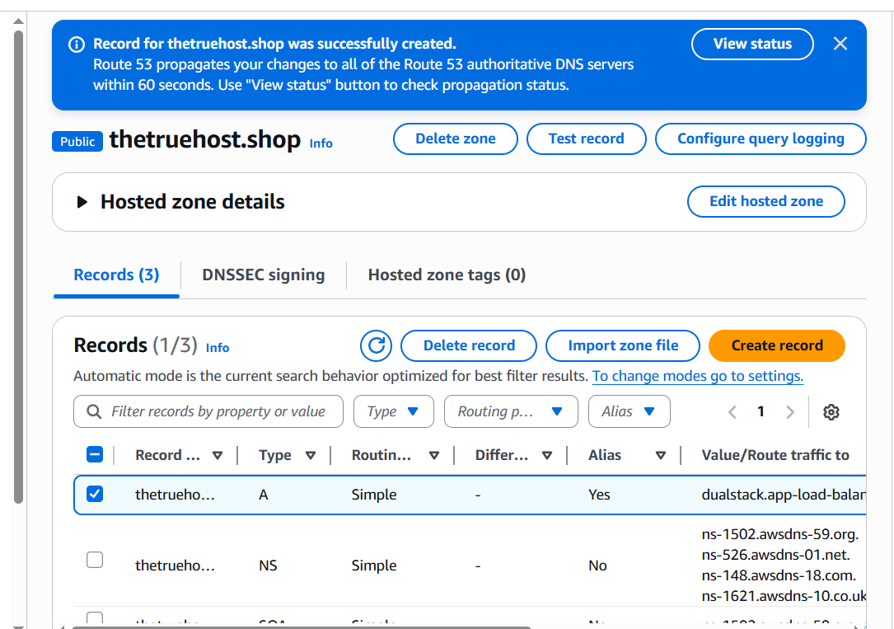
- Push the Application load balancer logs to s3.
Step-1:
Create s3 Bucket
Amazon s3 → Buckets → Click Create buckets
Select bucket type General purpose
Enter bucket Name
Select ACLs enabled in Object Ownership
Uncheck blocl all public access
Click Create bucket
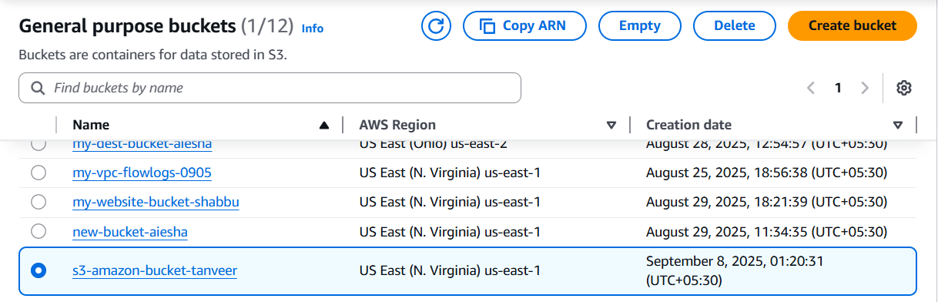
Add bucket policy

{
“Version”: “2012-10-17”,
“Statement”: [
{
“Sid”: “AWSALBLoggingPermissions”,
“Effect”: “Allow”,
“Principal”: {
“Service”: “logdelivery.elasticloadbalancing.amazonaws.com”
},
“Action”: “s3:PutObject”,
“Resource”: “arn:aws:S3:::s3-amazon-bucket-tanveer/AWSLogs/234542554489/*”
}
]
}

Go to S3bucket → select your bucket → permissions → edit policy → click Edit → Click save changes.
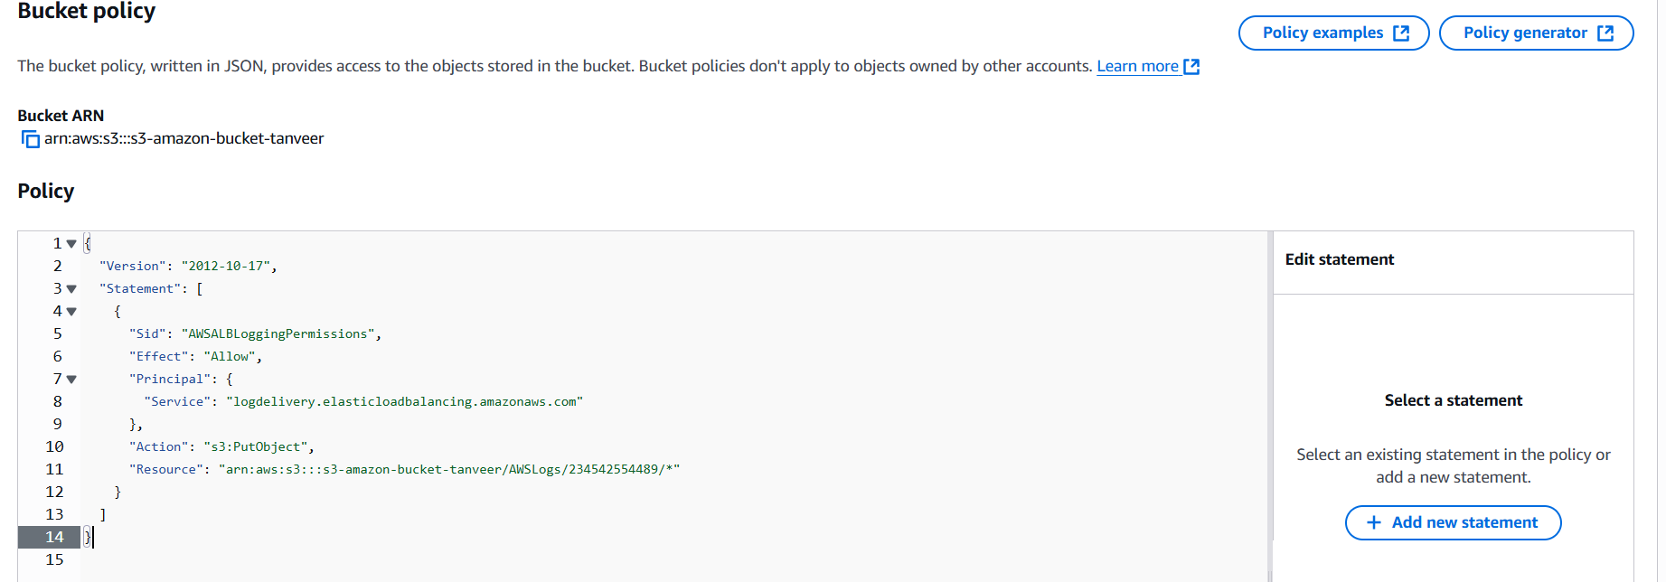
Step-2:
Enable access logging in ALB (Application load balancer)
EC2 → Load balancer → Select your ALB → click on Attributes tab → Click Edit → Enable access log → Add S3 url → Click Save changes.
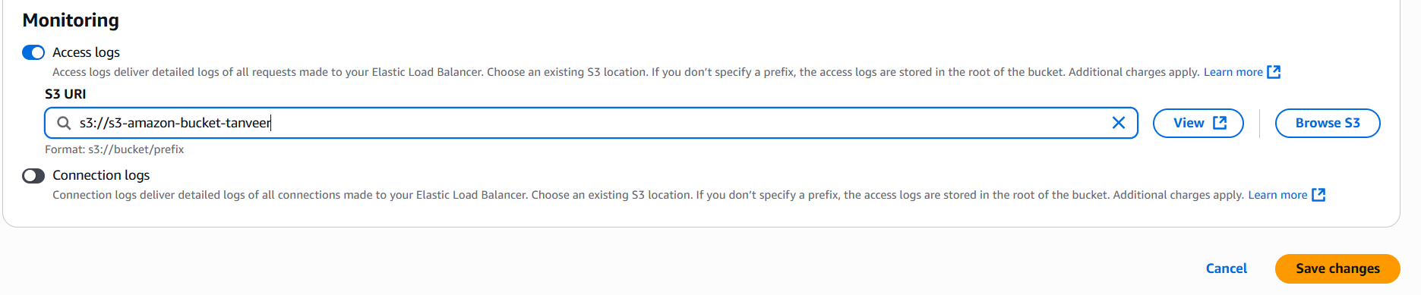
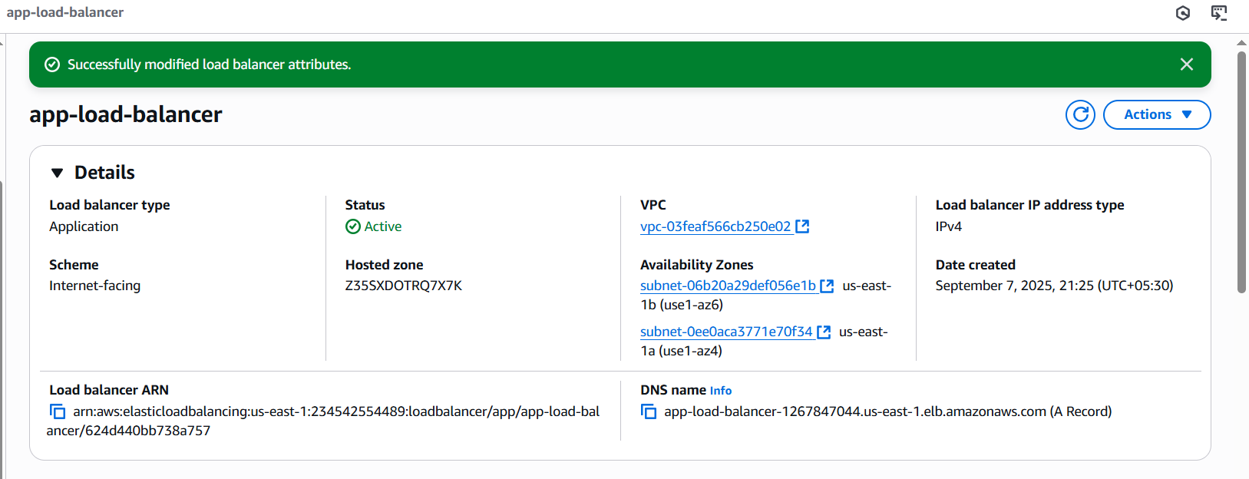
Now verify logs in S3 bucket
